A project Report on

## PODCAST PLUS: A Redux-Inspired App with Dynamic Themes For Android

BACHELOR OF COMPUTER APPLICATION

Devanga Arts College,

(Affiliated to Madurai Kamaraj University)

Aruppukottai-626101.

Submitted

By

**S.SATHEESH KUMAR (Reg No:C0S41821)**

**C.MANOJ PANDI (Reg No:C0S41812)**

**V.MONESH (Reg No:C0S41815)**

**S.GAJENDRA PRABU (Reg No:C0S41806)**

Under the Guidence of

Mr. V.GNANASEKARAN M.Sc.,

Devanga Arts College

(Affiliated to Madurai Kamaraj University)

Aruppukottai-626101

**Introduction:**

A podcast is a program made available in digital format for download over the Internet for example. An episodic series of digital audio files that a user can download to a personal device to listen to at a time of their choosing Podcasts are primarily an audio medium, with some programs offering a supplemental video component streaming applications and podcasting services provide a convenient and integrated way to manage a personal consumption queue across many podcast sources and playback devices. There are also podcast search engines, which help users find and share podcast episodes. The serial podcast being played through the Apple podcast app on iphone A podcast series usually features one or more recurring hosts engaged in a discussion about a particular topic or current event. Discussion and content with in a podcast can range from carefully scripted to completely improvised. Podcasts combine elaborate and artistic sound production with thematic concerns ranging from scientific research to slice-of-life journalism. Many podcast series provide an associated website with links and show notes, guest biographies, transcripts, additional resources, commentary, and occasionally a community forum dedicated to discussing the show’s content.

**Overview:**

The cost to the consumer is low, with many podcasts free to download. Some podcasts are underwritten by corporations or sponsored, with the inclusion of commercial advertisements. In other cases, a podcast could be a business venture supported by some combination of a paid subscription model, advertising or product delivered after sale. Because podcast content is often free, podcasting is often classified as a disruptive medium, adverse to the maintenance of traditional revenue models. Podcasting Is the preparation and distribution of audio files using RSS feeds to the devices of subscribed users. A podcaster normally buys this service from a podcast hosting companies then distribute these audio files to streaming services, such as apple and Spotify, which users can listen to on their smartphones or digital music and multimedia players, like an iphone. Podcasting, once an obscure method of spreading audio information, has become a recongnized.

EMPATHY MAP

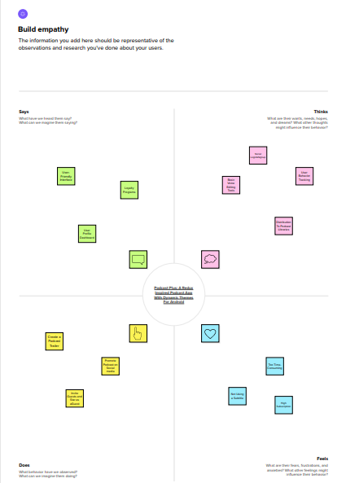

IDEATION & BRAINSTROMING MAP

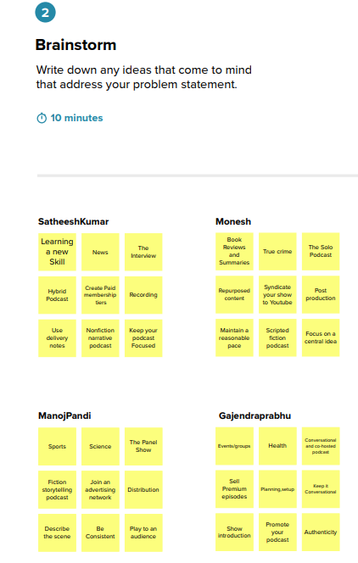

GROUP IDEAS

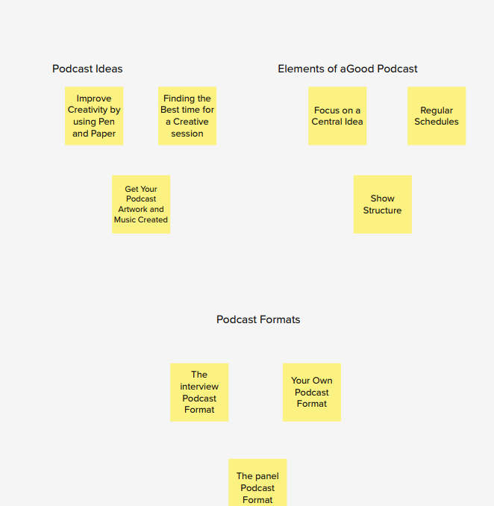

PRIORITIZE

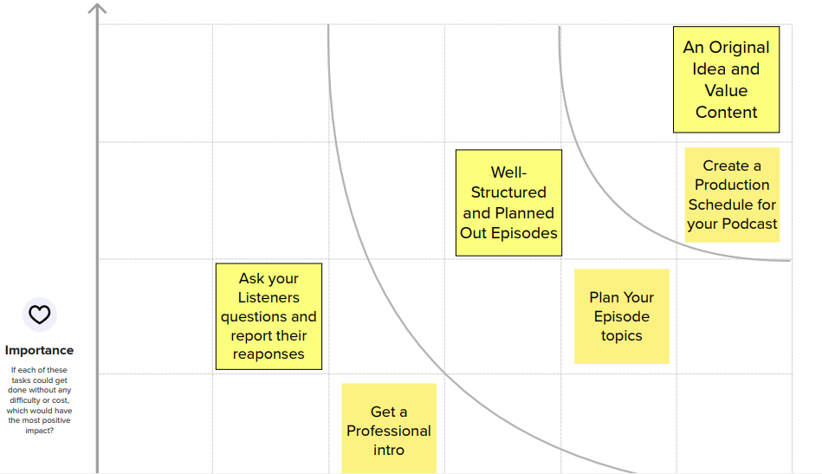

RESULT

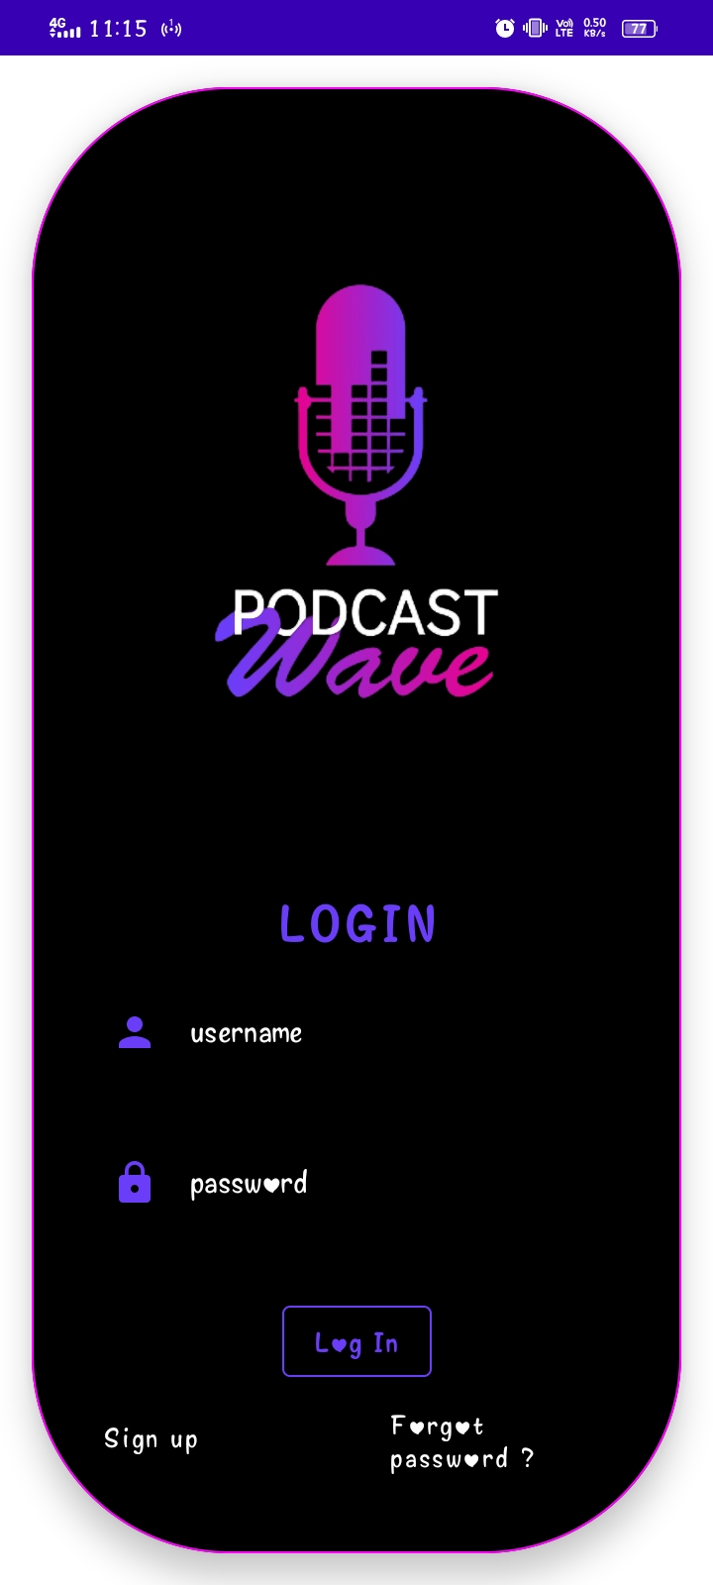

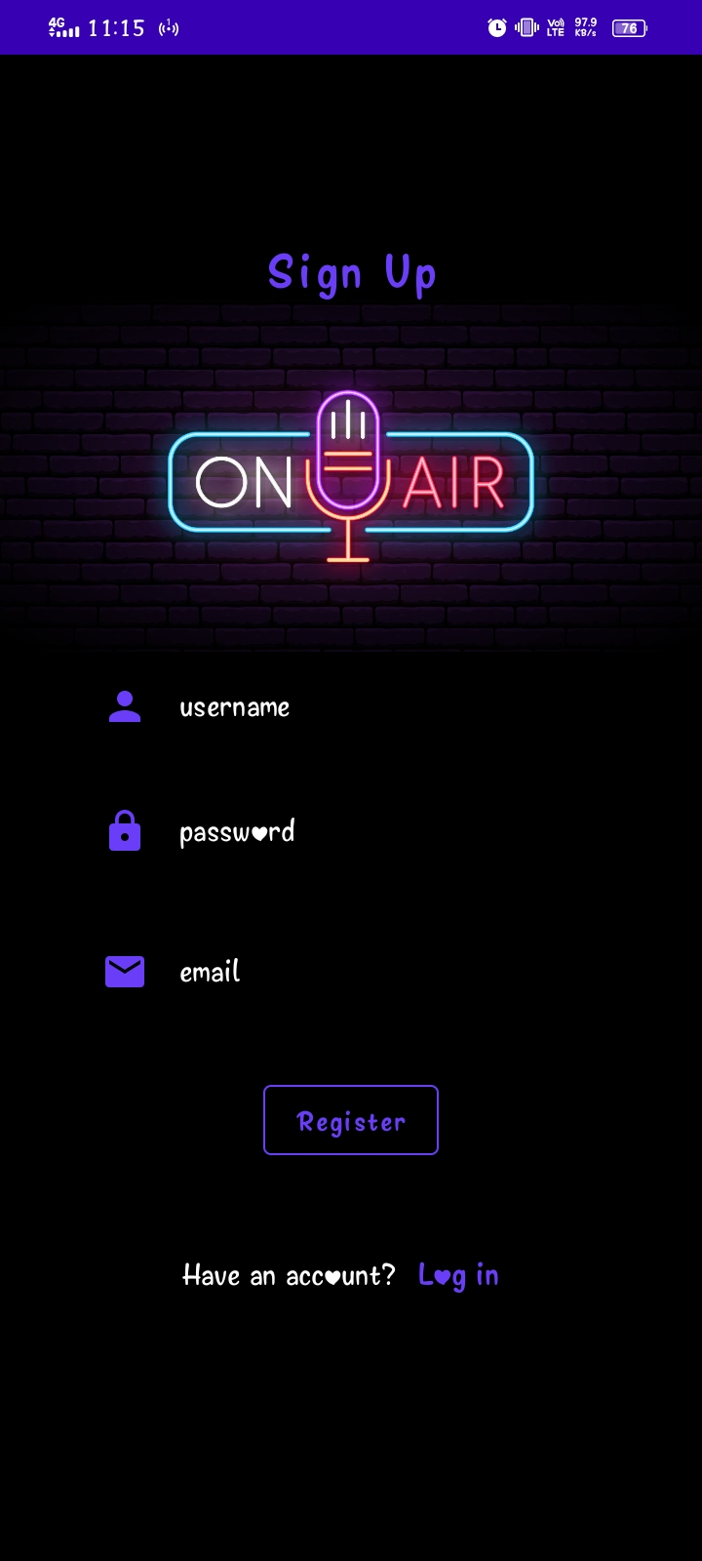

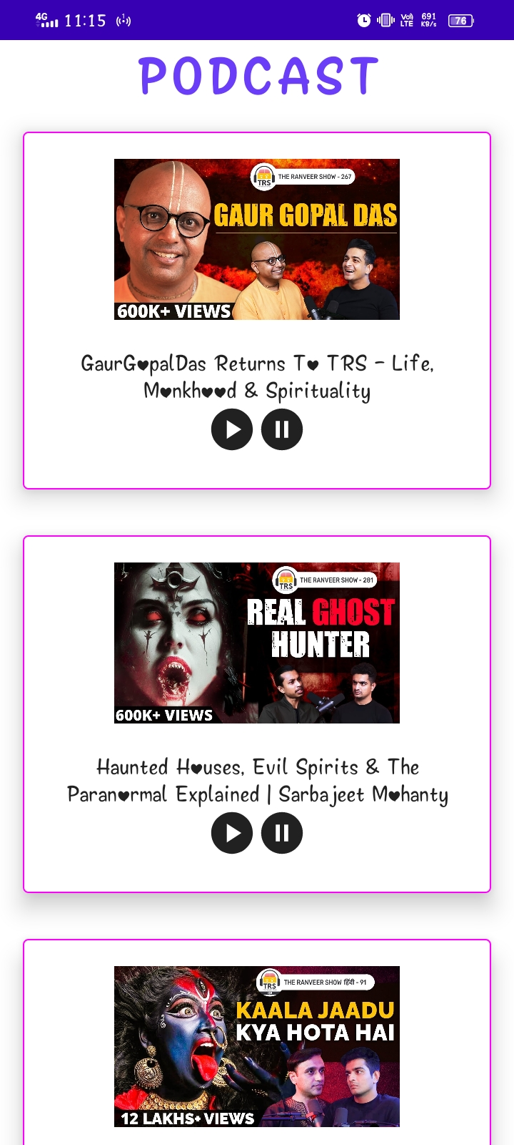

ADVANTAGES & DISADVANTAGES

Business podcasts come in all shapes and sizes, such as a presentation to prospective customers or a new policy announcement to employees. What they have in common is that they are audio or video files you send to the internet. Anyone who needs to see or hear them can stream the files or download them to a computer, smartphone or media player for listening or viewing.

ADVANTAGE: Convenience

One of the benefits of podcasts is that you don’t have to worry that your sales pitch. A listener can download or stream the file and replay it at whatever time is convenient for him. Even while jogging or driving to work. If someone chooses to subscribe to your podcast feed, he can get any podcasts of interest downloaded automatically. If you want all your employees to hear what you have to say. Podcasting is often easier than trying to get everyone together for one meeting.

DISADVANTAGE: Accessibility

If you want to reach an audience that doesn’t have access to the internet, then podcasting isn’t the way to it. Podcasts-especially video podcasts, according to the university of Minnesota Duluth are often large files, which also makes them hared to access for anyone with a slow internet connection. If you want to make an audio podcast available to a customer who’s hearing impaired or anyone who doesn’t have a compatible player, you need to turn the material into a written transcript as well. As the importance of podcasts grows though, accessibility issues are mitigated.

ADVANTAGE: Easy

Making a podcast is fairly simple. All you need is a computer or smartphone, software to record to your presentation and a connection to upload it to the internet if you’re looking to reach a wide audience, there are multiple sites that make podcasts available to listeners, including I tunes. You can buy software packages that also enable you to edit podcasts, add sound effects or store past podcasts for you to use later. Editing improves the quality of your finished podcast. But it does take more work.

DISADVANTAGE: Loss Of Control

Like any other digital medium, podcasts are easy to share. If you use someone else’s copyrighted material in your podcast, you have to take steps to protect it against unauthorized copying and file sharing. When it’s your own copyrighted material, the same problem applies unless you’re okay with it being passed around. If your podcast to employees includes confidential company material, anyone who accesses it can learn information about your business you’d rather keep secret.

**APPLICATIONS**

Overcast offers a simple yet powerful platform for listening to podcasts. You can browse podcasts, purchase episodes, and subscribe to podcasts to get notifications when new episodes come out. Overcast also features a wide range of powerful features to help you get the most out of your listening experience, including the unique Smart Speed, which lets you speed up playback without distorting audio. You can also listen to podcasts during your commute with CarPlay, use Voice Boost to improve audio quality, and set sleep timers for nighttime listening. Overcast is also a great choice for privacy-focused users as it promises to not track or sell sensitive user data.

Google Podcasts is an entirely free podcast app that hosts a large selection of popular podcasts. If your favorite podcast isn’t included on the platform, you can add it by entering its RSS feed. You can subscribe to podcasts, download episodes for offline listening, and start a queue to listen to episodes in a specified order. One of Google Podcast’s unique features is its Explore Topics section, which recommends podcasts based on the podcast episodes you’ve listened to. A history of all the podcasts you’ve listened to is saved under the Activity section, making it easy to go back and find your favorite episodes, and the Trim Silence feature saves time by cutting out dead air.

Spotify stands out from other apps on our list as it’s the only one to double as a full-fledged music streaming service. For podcast enthusiasts, Spotify hosts a wide range of popular and original podcasts, and you can follow podcasts to get notifications for new episodes. To discover new podcasts, you can browse Spotify’s curated collections or search for podcasts by category. Spotify is also one of the best and most popular music streaming services available, giving users access to a massive music catalog, curated playlists, and custom radio stations.

Stitcher is a powerful podcast player with a sleek, user-friendly interface and advanced playback controls. Users can search for their favorite podcasts or browse Stitcher’s weekly top picks to discover new podcasts. You can also browse curated collections featuring podcasts that cover specific topics and categories. Like Spotify, Stitcher also hosts its own original podcasts, though some require an upgrade to Premium to access. Stitcher stands out largely because of its various playback features that let users control their listening experience, including episode skips, fast forwards and rewinds up to two minutes, and sleep timers.

Apple Podcasts is one of the most popular podcast players and the best podcast app for iPhone users. The app is completely free and includes over 30 million episodes you can stream or download for offline listening. Apple Podcasts stands out thanks to its Siri integration, which lets users ask Siri for podcast recommendations and control podcast playback with their voice. You can browse Apple’s curated podcast collections to discover new shows or find podcasts by genre. Apple Podcasts even lets you search for podcasts and podcast episodes based on topics or people mentioned in the show’s transcript

Castbox is a feature-rich podcast player that offers a wide range of unique content to keep users entertained. Castbox gives you access to millions of popular podcast episodes that cover everything from news to pop culture and more, and unlike other podcast apps, you can listen to audiobooks, FM radio, guided meditations, and white noise. Users receive personalized podcast recommendations based on their listening history, and you can use features like Volume Boost, Trim Silence, and sleep timers to personalize your listening experience. The app also supports CarPlay, making it great for commuters, and lets users interact with community members through posts and comments.

If you like creating podcasts as much as you like listening to them, Podbean is the best podcast app for you. Podbean lets you browse, stream, and download over 50 million popular podcast episodes, and you can enhance your listening experience with features like intelligent speed adjustments, volume boost, and customizable playlists. You can search for podcasts by name, get personalized recommendations, and even participate in interactive livestreams to engage with hosts and community members. Podbean stands out from other apps thanks to its audio recording feature, which lets users record and edit podcasts directly in the app.

. Podcast Addict is a fully customizable podcast player that lets users take complete control of their listening experience. It’s the only app on our list that lets you manage podcast, audiobook, news, radio, SoundCloud, and YouTube channels so you can view and listen to all your favorite content in a single app. You can search for podcasts through Podcast Addict, Apple Podcasts, or The Podcast Index, and the app recommends podcasts based on your active subscriptions. Podcast Addict also offers unique automation features that allow users to automatically update, download, and delete podcast episodes based on custom parameters.

CONCLUSION

In conclusion, the podcast app project is a mobile application that provides users with a convenient and easy way to browse, search, and listen to podcasts. This project utilizes various components and functionalities to create an intuitive user interface that enhances the user experience. One of the key features of the podcast app is its ability to fetch podcast data from RSS feeds. This allows users to discover new podcasts and stay up-to-date with their favorite shows. Additionally, the app’s audio player provides a seamless listening experience, making it easy for users to enjoy their favorite podcasts on the go. Overall, the podcast app project is a valuable tool for podcast enthusiasts, providing a user-friendly platform for discovering and listening to podcasts. By utilizing the components and functionalities of android studio, this project is able to provide a seamless and enjoyable user experience..

FUTURE SCOPE

Before we dive into the features and qualities of a great podcast, let’s, first of all, understand [what a podcast is](https://podcastgang.com/blog/what-is-a-podcast/). Simply put, a podcast is a series of spoken, audio episodes, that is often focused on a particular topic or theme, like technology, startups, etc. Most podcasts today are only audio, although there are video podcasts too.

In creating a successful podcast show, the host plays an important role. In Fact, the host shoulders the success of it because he/she is to create good content, find the right guest, needs to be very skillful and as well become an expert in the subject matter.

Though there is no general or particular formula that podcasts share but the ones listed below are shared by most successful podcasts. So, take them and start creating successful podcast.

Being consistent with your podcast is vital, just so your listeners can keep up with your timing. If your podcast is daily, weekly, or monthly, stick to it and don’t skip a day or week or month. People like to know that your podcast will be waiting for them at a particular time. Not being consistent, can easily make them lose interest in you and your work.

Endeavor to get [quality sound equipment](https://podcastgang.com/blog/important-podcasting-equipment-to-buy/) for the production of your work and ensure that your audio is clear so that your listeners don’t get worked up with your podcast. No one wants to listen to a podcast that sounds like crap or sounds creepy. Invest your time and energy in giving your work a big shot. But then if you cannot handle this properly, you can seek the assistance of someone who can give you nice production.

As a host, how much of the topic do you know? Do you want to discuss a topic because it’s trending and then, you have little or no knowledge about it. For every topic , you need to be well grounded in it, that is the only way your audience will be enlightened listening to you. Prepare and research your topic very well so as to stay focused and having a clear path of the conversation. Do not even let your listeners get lost along the way. So, always keep your discussions pertinent to the topic of discussion or subject matter.

SOURCE CODE

UserClass Code:

package com.example.podcastplayer

import androidx.room.ColumnInfo

import androidx.room.Entity

import androidx.room.PrimaryKey

@Entity(tableName = "user_table")

data class User(

@PrimaryKey(autoGenerate = true) val id: Int?,

@ColumnInfo(name = "first_name") val firstName: String?,

@ColumnInfo(name = "last_name") val lastName: String?,

@ColumnInfo(name = "email") val email: String?,

@ColumnInfo(name = "password") val password: String?

)

UserDaoClassCode:

package com.example.podcastplayer

import androidx.room.*

@Dao

interface UserDao {

@Query("SELECT * FROM user_table WHERE email = :email")

suspend fun getUserByEmail(email: String): User?

@Insert(onConflict = OnConflictStrategy.REPLACE)

suspend fun insertUser(user: User)

@Update

suspend fun updateUser(user: User)

@Delete

suspend fun deleteUser(user: User)

}

UserDatabaseClass:

package com.example.podcastplayer

import android.content.Context

import androidx.room.Database

import androidx.room.Room

import androidx.room.RoomDatabase

@Database(entities = [User::class], version = 1)

abstract class UserDatabase : RoomDatabase() {

abstract fun userDao(): UserDao

companion object {

@Volatile

private var instance: UserDatabase? = null

fun getDatabase(context: Context): UserDatabase {

return instance ?: synchronized(this) {

val newInstance = Room.databaseBuilder(

context.applicationContext,

UserDatabase::class.java,

"user_database"

).build()

instance = newInstance

newInstance

}

}

}

}